# BAIT3173 Integrative Programming

# 

# **Sample Code Readme**

## Instructions

To run any PHP web application, you need to:

1. Copy the PHP NetBeans project to the C:\xampp\htdocs folder.
2. Start the XAMPP Control Panel
3. Start the Apache module

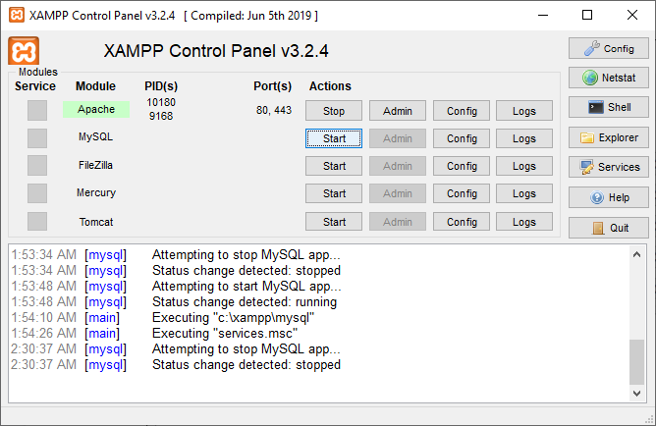

## Chapter1Example1 (Web Application)

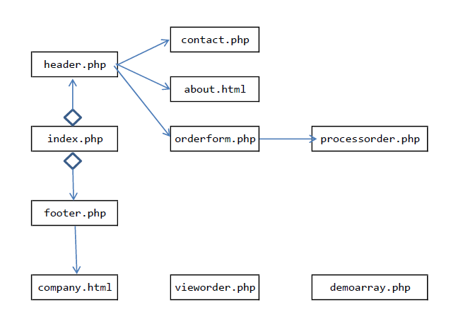

## Chapter1Example2a (Object-oriented PHP)

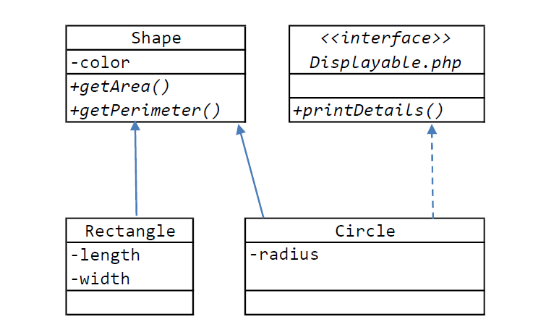

## Chapter1Example2b (Inheritance with Web Pages)

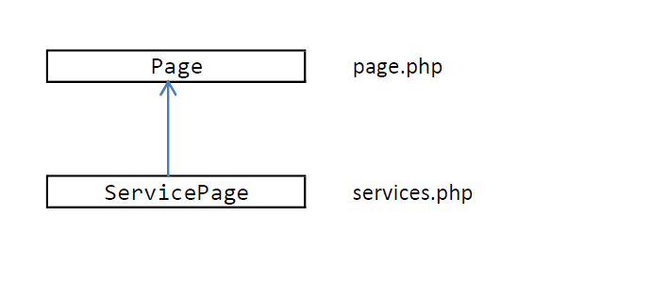

## 

## Chapter1Example3 (Web Application with Database)

Instructions

Prior to running this project, you need to:

1. Create the mydb database
2. Create the Authorized_Users table
3. Create the Products table and insert some data
4. Create the mydb database
5. At the XAMPP Control Panel
6. Start the Apache module
7. Start the MySQL module

## 

2. Start the Admin console for MySQL, i.e. phpMyAdmin

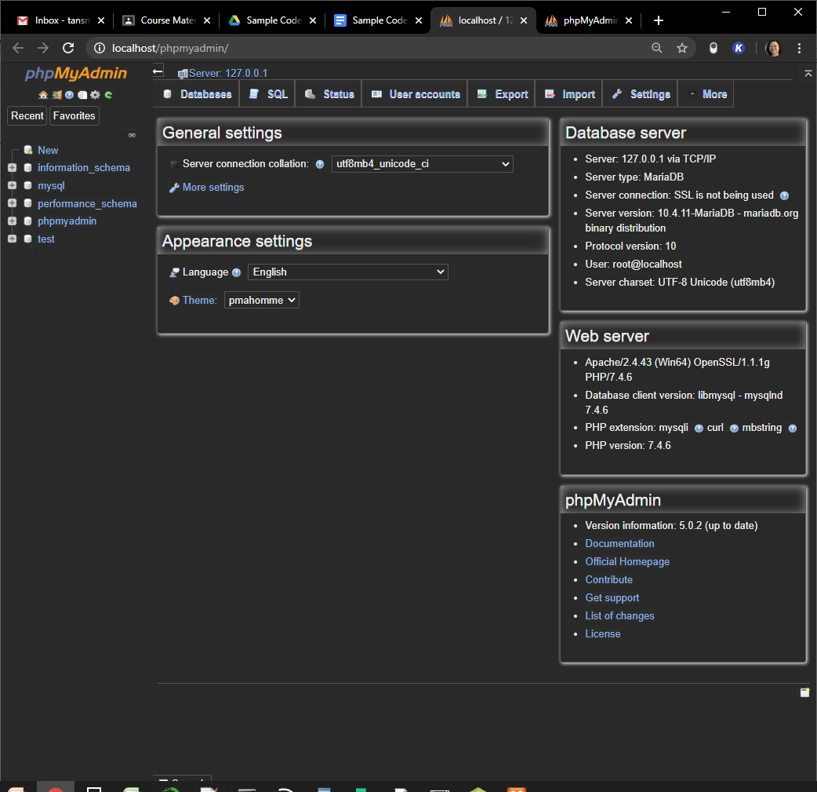

3. Create a new database named **mydb**

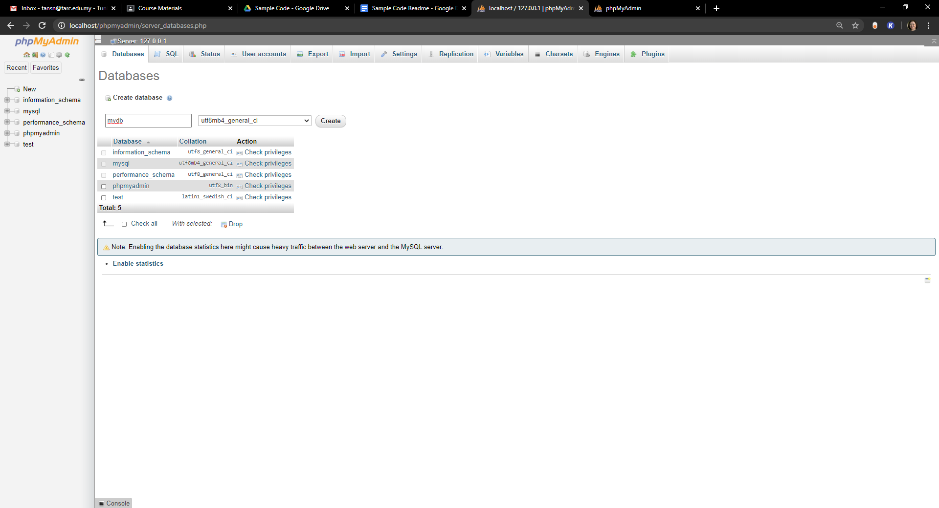

4. Click the Import tab

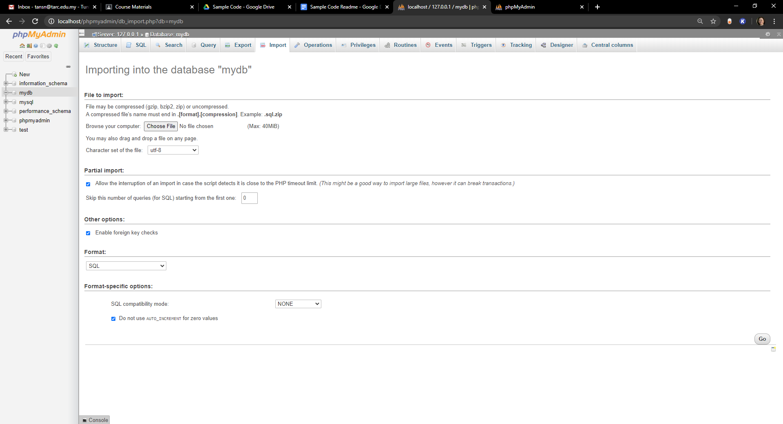

5. Click Choose File, browse to and select the usertable.sql file. Then, click Go.

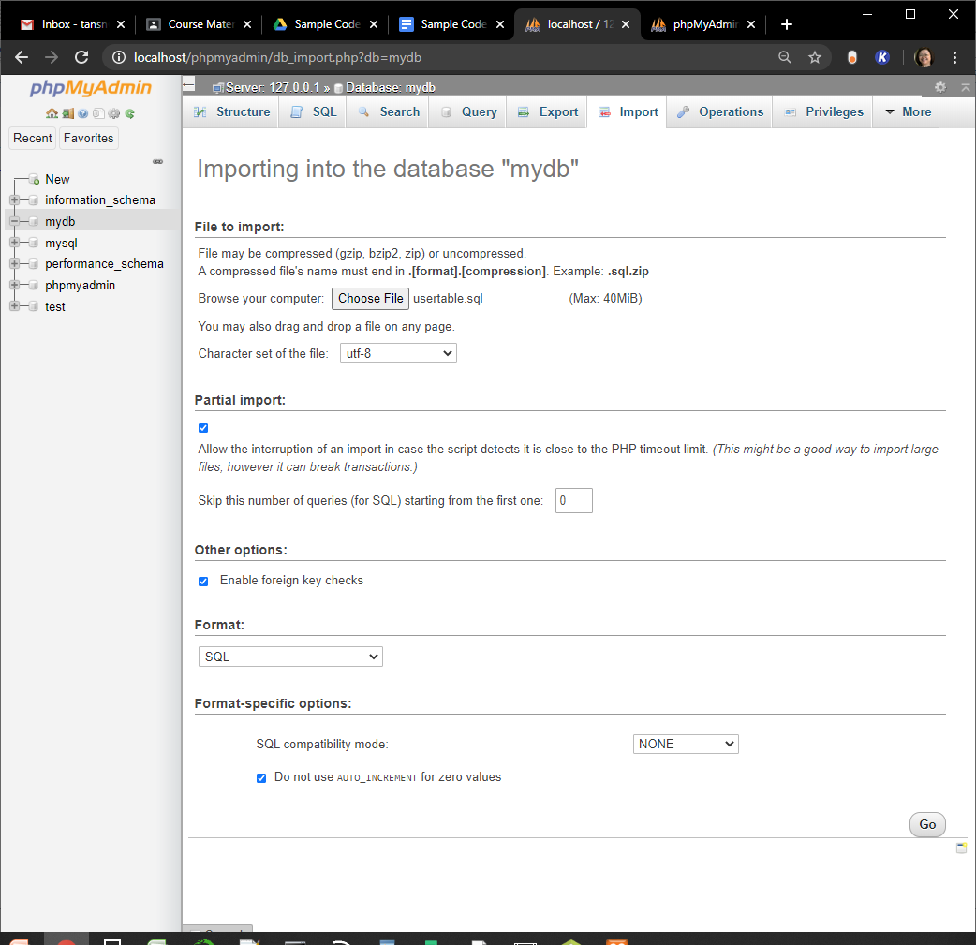

The tables should be successfully created:

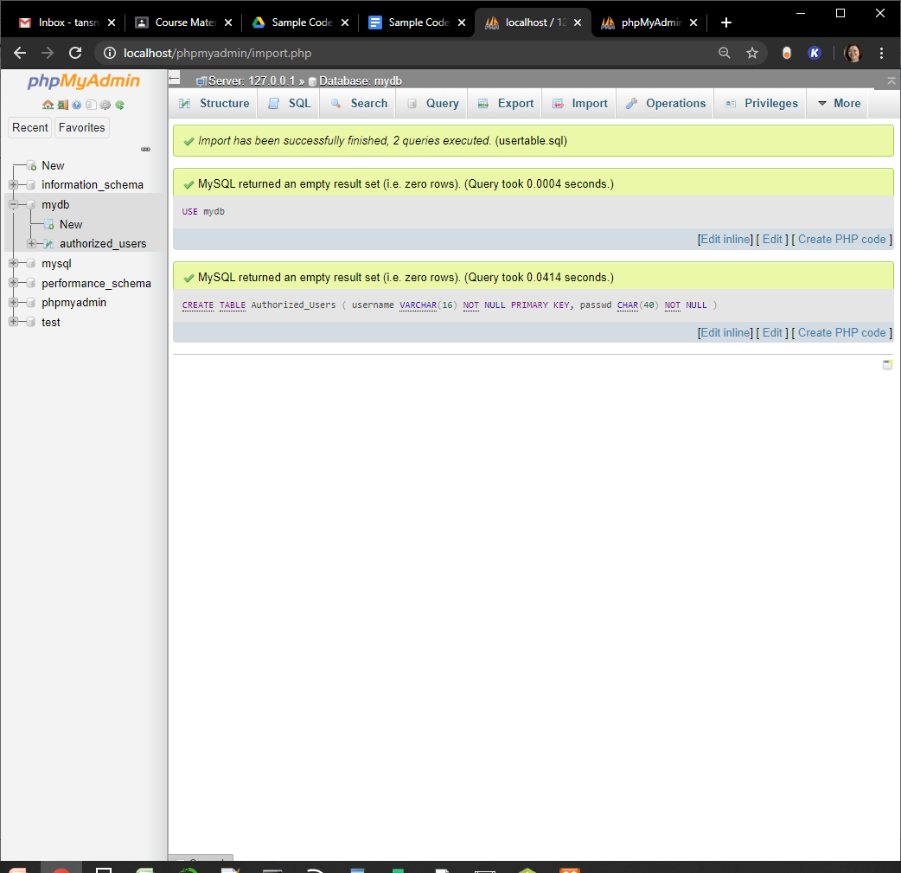

B. Create the Products table and insert some data

Follow steps A 4 to 5 for the outdoorsupplies.sql file.

### 

### Changing the Database Password

The sample code assumes that the User name is “root” and password is “secret”. By default, there is no password set for the root user.

To change/set a password for root:

1. Click User accounts.

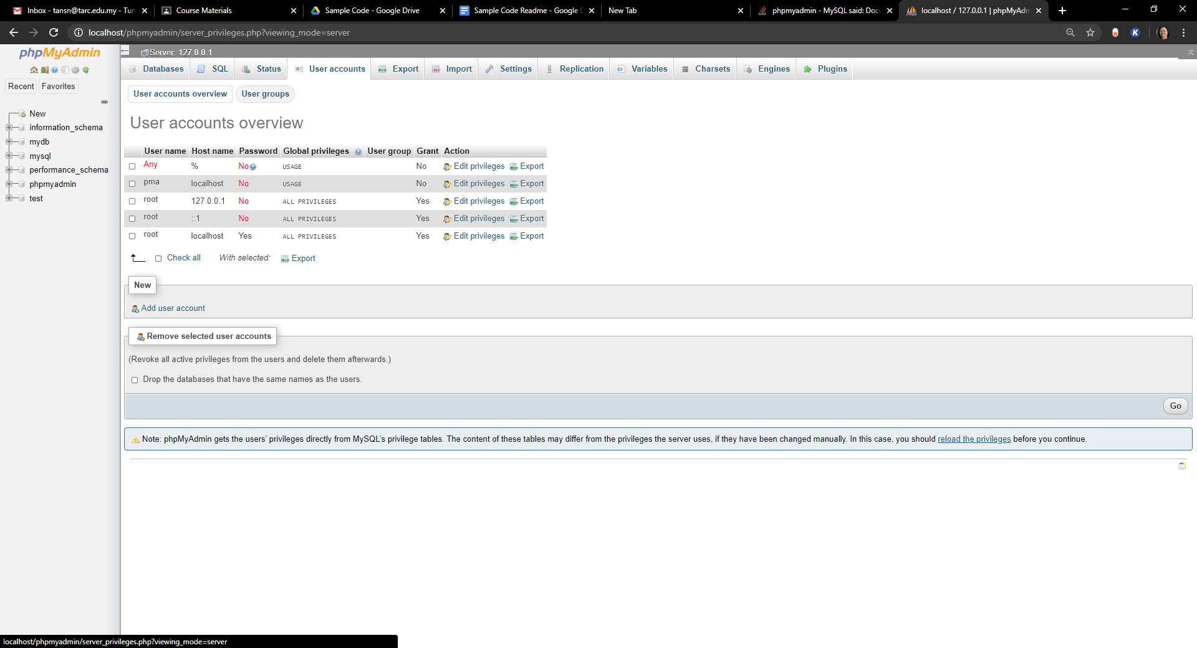

1. Click Edit privileges for User name root and Host name localhost. Click Change password

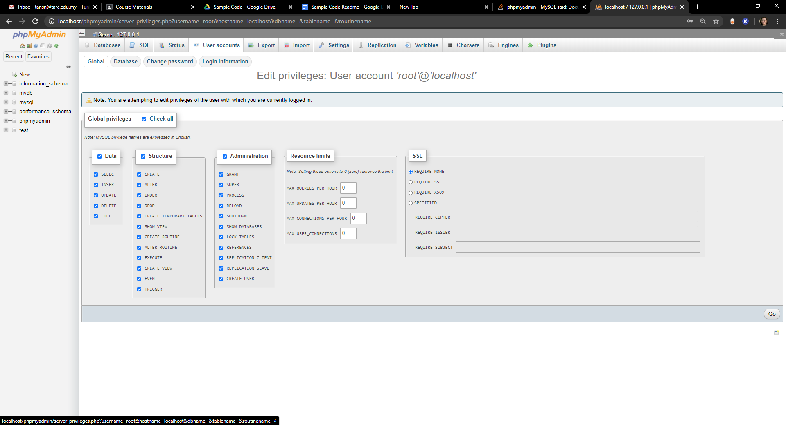

1. Enter the new password. Then, Retype the new password.

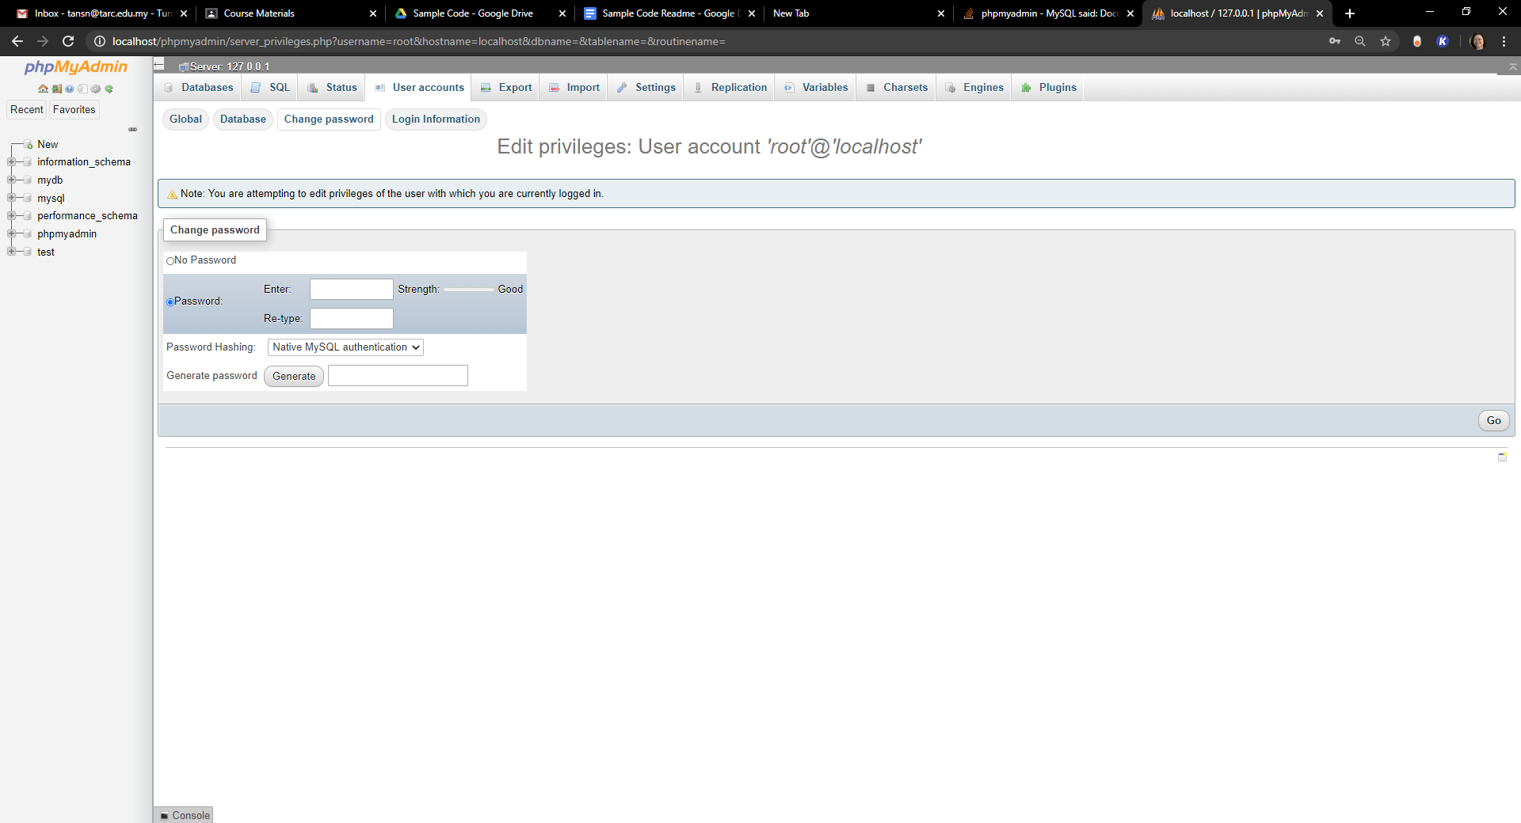

1. In Windows Explorer, browse to and open the file C:\xampp\phpMyAdmin\config.inc.php using Notepad.
2. Under /* Authentication type and Info */, set the password to your new password.

